Are you a Victim of Domestic Abuse?
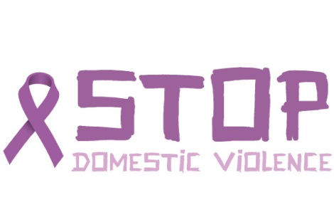
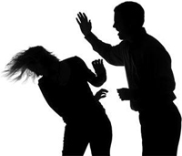
What is Domestic Abuse?
Domestic abuse takes many forms. It is a pattern of controlling tactics and a variety of aggressive and manipulative behaviours from one adult towards another, most often within an intimate relationship. It may be physical harm or threats and can be involved emotionally or psychological abuse. It may involve someone doing or saying things of a sexual nature that makes you feel bad or that physically hurt you or someone else. It can involve someone socially isolating or financially abusing you.
Useful Telephone numbers:-
24 hours a day - 7 days a week-
365 days a year
Halton Domestic Abuse service: 0300 111 247
Police Domestic Abuse service: 01244 613 937
How does Domestic Abuse make us feel?
- Low in self-esteem and confidence
- Depressed
- Isolated
- Lonely
- Unloved
- Insulted & Belittled
- Ashamed/Degraded
- Useless & Worthless
- Punished
- Unwell
- Stupid
- Out of Control
- Suicidal

